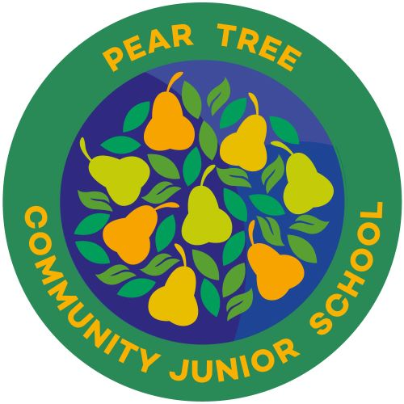

Class Teacher
Required from September 1st 2024
Permanent - Full time
Main Scale Points 1-6

Pear Tree Community Junior School is seeking to appoint an excellent teaching practitioner with high expectations of pupil progress and a drive for self-development.

Pear Tree Community Junior School is in the heart of a vibrant, diverse and culturally rich community.
The school has built an excellent reputation across Derby for its commitment to providing the best education for all its children and supporting the community to grow. The school’s values of Trust, Care and Grow are lived out on daily basis ensuring the school, its staff and its pupils flourish. We are a friendly school with a supportive team ethos. We are passionate about ensuring that every child makes progress and develops a love of learning.
What we’re looking for:
- A commitment to improving pupil outcomes
- A passion for personal and professional development
- A desire to innovate and contribute to a dynamic team
- Dedication to providing highly effective teaching
- A collaborative spirit and a love for working with diverse communities

Why Pear Tree?
- A supportive and inclusive environment where every voice is valued
- Opportunities for continuous professional development and growth
- A commitment to staff well-being and work-life balance
- Access to resources and support to enhance teaching practices
- The chance to make a real difference in the lives of our students

Visits to our school are warmly welcomed, please contact the school office on 01332 760610 to arrange a mutually convenient time.
How to apply
Equality and diversity matters to us. If you think you’d be suited to one of our roles we’d love to hear from you regardless of age, disability status, ethnicity, gender, religion or sexuality.
Please complete the online application form which can be found on the Transform Trust website at http://www.transformtrust.co.uk/vacancies.

Any questions or queries should be directed to:
Natalie Bounds at Pear Tree Community Junior School, Pear Tree Street, Derby, DE23 8PN.
Email: n.bounds@peartreej.derby.sch.uk
Telephone: 01322 760610
Closing date for applications: 4pm Wednesday 15th May 2024
Interviews will be held on: Monday 20th May 2024
Information supporting the advertised post can be found within the recruitment pack uploaded with the vacancy advert

